# CHAPTER-1

**INTRODUCTION**

**1.1 PROLOGUE**

In Vitro Fertilization (IVF) is a cutting-edge assisted reproductive technology used to address infertility and assist individuals and couples in conceiving a child. Unlike natural conception, IVF involves fertilization outside the human body, in a carefully controlled laboratory setting. This innovative procedure has revolutionized the field of reproductive medicine, offering hope to those facing challenges in conceiving naturally.

IVF has proven to be a lifeline for many couples struggling with various infertility issues. It has also provided family-building opportunities for same-sex couples and single individuals who aspire to become parents. Through IVF, fertilization occurs in a specialized laboratory dish and is monitored throughout their development into embryos. The resulting embryos are cultured in advanced incubators, which mimic the optimal conditions required for healthy growth. Embryo selection is a critical part of the process, with the healthiest embryos being chosen for transfer into the uterus.

IVF success rates can vary based on a range of factors, including the age of the woman, the cause of infertility, and the quality of the embryos. While IVF has brought joy to millions of families worldwide, it is essential to recognize that it may not always result in pregnancy and requires careful consideration, medical expertise, and emotional support throughout the journey.

As IVF continues to evolve and improve, it remains at the forefront of reproductive medicine, offering hope and possibilities to those seeking to build their families. The ethical considerations, research advancements, and ongoing dedication of medical professionals contribute to the ongoing success and transformative impact of IVF in the lives of hopeful parents and the field of assisted reproduction.

The selection of the most viable embryo is the crucial step of an IVF process, this can be achieved by analyzing the development of the embryo. The development of an embryo refers to the process by which a fertilized egg undergoes a series of remarkable transformations, ultimately leading to the formation of a multicellular organism.

The developmental stages of an embryo can be summarized as follows:

* Fertilization: The journey begins with fertilization, where a sperm penetrates and combines with the egg to form a single-celled zygote. This occurs in the fallopian tube shortly after ovulation.
* Cleavage: The zygote starts dividing rapidly through a process called cleavage. Initially, the embryo consists of a cluster of cells called blastomeres. Over the next few days, the number of cells increases through multiple divisions.
* Morula: After several rounds of cell division, the embryo transforms into a compact ball of cells known as a morula. At this stage, it consists of about 16 to 32 cells.
* Blastocyst Formation: The morula continues to divide, forming a fluid-filled cavity within it. This leads to the development of the blastocyst, a structure with two distinct parts: the inner cell mass, which eventually becomes the fetus, and the outer cell mass, which will form the placenta.
* Hatching: The blastocyst undergoes a process called hatching, where it breaks out of the protective outer layer (zona pellucida) surrounding it. This allows the blastocyst to interact with the uterine lining for implantation.
* Implantation: The hatched blastocyst attaches to the uterine lining and begins the process of implantation. This is a critical stage, as successful implantation is essential for a pregnancy to occur.
* Gastrulation: Following implantation, the blastocyst undergoes gastrulation, a complex process during which the three primary germ layers (ectoderm, mesoderm, and endoderm) are formed. These germ layers give rise to different tissues and organs in the developing embryo.
* Organogenesis: As the gastrulation progresses, the embryo undergoes organogenesis, during which major organ systems and structures begin to take shape. This is a period of rapid development and differentiation.
* Fetal Development: By the end of the embryonic stage, which is around the eighth week of gestation, the major organ systems are in place, and the embryo is now referred to as a fetus. Fetal development continues throughout the pregnancy until birth.

Understanding and accurately assessing the developmental stages of embryos during IVF is crucial for selecting the healthiest embryos for transfer into the woman's uterus. The close synergy between IVF and the observation of embryo development stages fosters a transformative approach to fertility treatments, leading to improved patient outcomes and fulfilling the dreams of countless individuals and families seeking reproductive solutions.

The sixteen timepoints which corresponding images are present in the dataset are-

Carnegie Stage 1: Fertilization to the First Cleavage

Carnegie Stage 2: Two to Four Cells

Carnegie Stage 3: Morula

Carnegie Stage 4: Early Blastocyst

Carnegie Stage 5: Blastocyst

Carnegie Stage 6: Blastocyst Hatching

Carnegie Stage 7: Implantation

Carnegie Stage 8: Bilaminar Embryo

Carnegie Stage 9: Amniotic Cavity Appears

Carnegie Stage 10: Formation of the Trilaminar Embryo

Carnegie Stage 11: Folding of the Embryo

Carnegie Stage 12: Formation of the Heart

Carnegie Stage 13: Formation of the Limb Buds

Carnegie Stage 14: Formation of the Pharyngeal Arch

Carnegie Stage 15: Completion of Organogenesis

Carnegie Stage 16: Fetal Period Begins

These Carnegie stages represent the different developmental milestones and events that occur during the initial eight weeks after fertilization, leading to the formation of a fully developed human fetus. The Carnegie stages serve as a standardized reference for researchers, clinicians, and embryologists to describe and understand the intricate process of human embryonic development.

**TERMINOLOGIES USED ABOVE:**

* Insemination: insemination is the technique in which semen with living sperms is collected from the male and introduced into female reproductive tract at proper time with the help of instruments.
* Polar body:Polar bodies are tiny cells that are extruded during oocyte meiosis and are generally considered not essential for embryonic development.
* Pronuclei:A pronucleus is the haploid nucleus of either the egg or sperm, both present in the fertilized egg prior to their fusion
* Blastocyst: A blastocyst is a cluster of dividing cells made by a fertilized egg. It's the early stage of an embryo

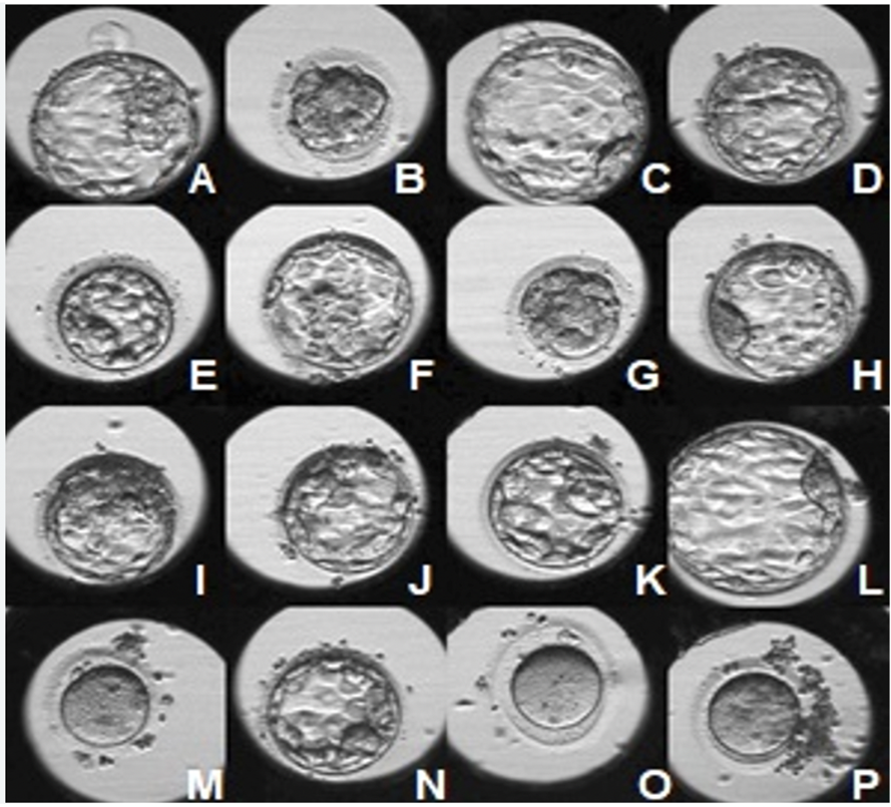

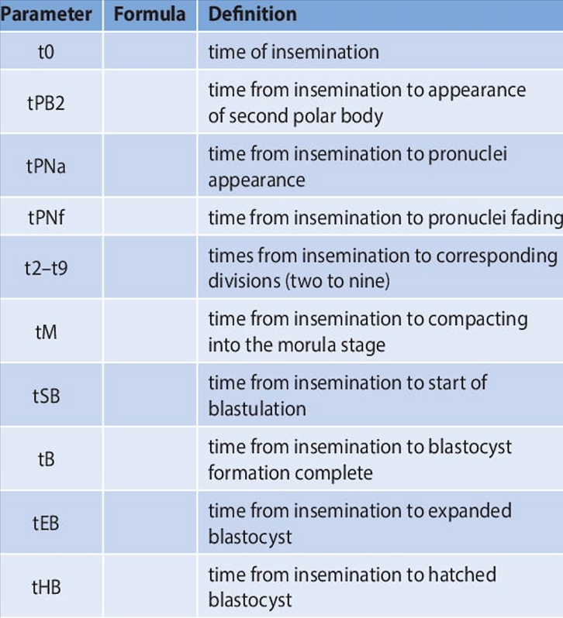

* ‘A’ corresponds to t0 development phase of the embryo implanted.
* ‘B’ corresponds to tPB2 development phase of the embryo implanted.
* ‘C’ corresponds to tPNa development phase of the embryo implanted.
* ‘D’ corresponds to tPNf development phase of the embryo implanted.
* ‘E’ corresponds to t2 development phase of the embryo implanted.
* ‘F’ corresponds to t3 development phase of the embryo implanted.
* ‘G’ corresponds to t4 development phase of the embryo implanted.
* ‘H’ corresponds to t5 development phase of the embryo implanted.
* ‘I’ corresponds to t6 development phase of the embryo implanted.
* ‘J’ corresponds to t7 development phase of the embryo implanted.
* ‘K’ corresponds to t8 development phase of the embryo implanted.
* ‘L’ corresponds to t9+ development phase of the embryo implanted.
* ‘M’ corresponds to tM development phase of the embryo implanted.
* ‘N’ corresponds to tSB development phase of the embryo implanted.
* ‘O’ corresponds to tEB development phase of the embryo implanted.
* ‘P’ corresponds to tHB development phase of the embryo implanted.

## 1.2 DOMAIN DESCRIPTION

Embryo development stage prediction system falls under the domain of assisted reproductive technologies and artificial intelligence in healthcare. The integration of AI into healthcare is transforming the industry, leading to more efficient diagnoses, improved patient outcomes, and enhanced healthcare delivery. However, it also raises important ethical, privacy, and regulatory considerations, highlighting the need for responsible and transparent use of AI technologies in healthcare settings.

This model specifically focuses on the field of In Vitro Fertilization (IVF) and embryo analysis using Time-Lapse Imaging Incubators (TLI). The domain involves the use of advanced imaging and deep learning techniques, such as Convolutional Neural Networks (CNNs), to analyze and predict the developmental phases of embryos during the IVF process.

Convolutional Neural Networks (CNNs) play a crucial role in the domain of assisted reproductive technologies. CNNs are a class of deep learning models that have shown remarkable success in image recognition tasks, making them well-suited for analyzing time-lapse images of developing embryos during the IVF process.

The use of CNNs in this domain involves a multi-step process:

Image Preprocessing: Time-Lapse Imaging Incubators capture a series of images of developing embryos at regular intervals. These images are preprocessed to enhance their quality, remove noise, and normalize the data. Preprocessing is crucial to ensure that the CNN receives consistent and relevant information for accurate predictions.

Feature Extraction: CNNs are designed to automatically extract relevant features from images. During the training phase, the CNN learns to identify patterns and unique characteristics in the time-lapse images that correlate with different stages of embryo development. This process involves multiple layers of convolution and pooling, which help to capture hierarchical features in the images.

Training and Learning: The CNN is trained on a large dataset of time-lapse images of embryos, along with corresponding labels indicating their developmental stages. The network adjusts its internal parameters through backpropagation and gradient descent, gradually improving its ability to recognize and classify different embryo stages based on the learned features.

Predictions: Once the CNN is trained, it can be deployed to predict the developmental stages of new embryos in real-time. As the time-lapse images are continuously captured during the IVF process, the CNN can process and analyze the images as they become available, providing dynamic and up-to-date predictions of embryo development.

The domain aims to address the challenges and opportunities in fertility treatments, where the ability to accurately assess embryo quality and development stages plays a crucial role in the success of IVF procedures. By leveraging modern AI methodologies and cutting-edge imaging technologies, the project aims to enhance the effectiveness and efficiency of embryo analysis, ultimately providing better insights into embryonic growth and improving the overall outcomes for infertile couples seeking reproductive solutions.

AI-driven embryo analysis can contribute to more personalized treatment plans for couples undergoing IVF. By predicting the developmental stages and quality of embryos, clinicians can tailor the selection and transfer process based on individual patient characteristics and medical history. This personalized approach can significantly increase the chances of a successful pregnancy while minimizing the risks associated with multiple embryo transfers.

One of the risks associated with IVF is the possibility of multiple pregnancies, which can lead to complications for both the mother and the babies. This model can aid in selecting the most viable single embryo for transfer, reducing the likelihood of multiple pregnancies while maintaining high success rates.

The intersection of reproductive medicine, time-lapse imaging, and deep learning is at the forefront of scientific research and technological advancements. This domain holds significant promise for revolutionizing the field of assisted reproduction, contributing to advancements in healthcare and fulfilling the dreams of countless individuals and families striving to conceive and build their families through IVF treatments.

## 1.3 OBJECTIVES

The objective of the project is to develop a predictive model that can accurately classify different developmental stages of embryos, offering valuable insights to fertility specialists and embryologists. By leveraging deep learning techniques, specifically Convolutional Neural Networks (CNNs), the model is expected to eliminate the necessity for manual embryo annotation and evaluation.

This innovative model aims to compress the three-dimensional time-lapse image data into a two-dimensional format, enabling efficient deep learning processing and reducing data to a manageable size. By employing advanced deep learning methods like CNNs, the model will forecast the development stage of human embryos, providing a dynamic and automated approach to embryo analysis during In Vitro Fertilization (IVF) procedures. The successful implementation of this model has the potential to enhance the accuracy and efficiency of embryo evaluation, ultimately contributing to improved IVF outcomes and fulfilling the aspirations of individuals and couples seeking to start or expand their families.

## PROJECT DEFINITION

The need for grading an embryo for the process of implantation is of utmost importance. It is essential to grade an embryo based on the morphological stages it has reached. The morphological stage the embryo is in ,is to be recognized first to proceed with the embryo grading. The model aims to create an innovative embryo development phase prediction system utilizing deep learning techniques, particularly Convolutional Neural Networks (CNNs). Through the analysis of images captured by time-lapse incubators during In Vitro Fertilization (IVF) procedures, the system will accurately predict and classify various developmental stages of embryos. An essential aspect of this project is to eliminate the dependency on manual embryo annotation and evaluation, streamlining the workflow for fertility specialists and embryologists. The successful implementation of this cutting-edge system is expected to revolutionize embryo evaluation, bolster IVF success rates, and provide invaluable insights to support hopeful families in their quest for parenthood

## 1.4 ORGANIZATION OF PROJECT REPORT

Chapter one of the project deals with the description of the domain and our project, including the Objective and scope of the project, the second chapter contains literature Survey analysis of the Project that attempts to describe the existing system. The existing system's advantages and disadvantages, the motivation for our project. The third chapter contains requirement specifications (functional and non-functional requirements). Also Hardware and Software requirements are specified. The Fourth chapter contains the implementation details with description of the methodology used and the system architecture, brief description of modules, and sequence diagrams with timelines. The chapter five has the discussion on the test plan inclusive of test cases. The sixth chapter has the conclusion and future scope of the project. Conclusion is a brief description of the project and the scope of how it is useful and its scalability in the near future.

# CHAPTER-2

**LITERATURE SURVEY**

## EXISTING SYSTEM

Embryo assessment is a critical step in in vitro fertilization (IVF) treatment, where embryos are evaluated based on morphological and developmental characteristics to select the best ones for transfer. Deep learning is a subfield of machine learning that has shown great potential in improving embryo assessment by analyzing images and videos of embryos. Some of the most notable systems include:

1)**A time-lapse deep learning system for early embryonic arrest prediction.**

The time-lapse deep learning system for early embryonic arrest prediction developed by Wong et al. (2018) uses a convolutional neural network (CNN) architecture called Inception-v3 for image classification. The CNN architecture is pre-trained on a large dataset of natural images, and then fine-tuned on a dataset of 258 embryos with known outcomes from a single IVF clinic. The time-lapse images of the embryos are processed using the Inception-v3 network to extract features, which are then used to train a support vector machine (SVM) classifier to predict early embryonic arrest.

**Limitations**

•Limited dataset: The study used a small dataset of 366 embryos from 72 patients, which may not be representative of the wider population.

•Limited Diversity: The study only included embryos from one ethnic group and one age group, which limits the diversity of the dataset.

•Limited variables: The model only takes into account a limited number of variables, such as cleavage rate and cell size, which may not capture all relevant information for predicting early embryonic arrest.

**Reference-**  Wong, C. C., Loewke, K. E., Bossert, N. L., Behr, B., De Jonge, C. J., & Baer, T. M. (2018).A time-lapse deep learning system for early embryonic arrest prediction. Human Reproduction,33(10), 1905-1913. doi: 10.1093/humrep/dey267

2**)A deep learning approach for predicting embryonic development in IVF.**

The DEEP-IVF system developed by Turan et al. (2019) is a deep learning model that uses convolutional neural networks (CNNs) and long short-term memory (LSTM) networks to predict embryonic development during in vitro fertilization (IVF) cycles.

The model was evaluated using a hold-out test set, and the results showed that it outperformed other existing prediction models in predicting blastocyst formation.

**Limitations**

•Limited dataset: The study used a small dataset of 519 embryos from 108 patients, which may not be representative of the wider population. This could limit the generalizability of the model to other populations and clinics.

•Limited diversity: The study only included embryos from one ethnic group and one age group, which limits the diversity of the dataset.

•Lack of external validation: The model has not been externally validated using independent datasets, which is important to ensure its generalizability to other clinics and patient populations.

**Reference-**Turan, V., Wong, C. C., & Son W. Y. (2019). DEEP-IVF: A deep learning approach for

predicting embryonic development in IVF. IEEE Transactions on Medical Imaging, 38(10), 2301-

2310. doi: 10.1109/TMI.2019.2891578

3)**A recurrent neural network model for early prediction of blastocyst formation using time_x0002_lapse images**

The recurrent neural network (RNN) model developed by Nguyen et al. (2020) is designed to predict blastocyst formation during in vitro fertilization (IVF) cycles using time-lapse imaging data.The time-lapse images of the embryos are pre-processed to extract features, including morphological, intensity, and texture features, which are then used as input to the LSTM network. .

The study suggests that the RNN model could be a useful tool for IVF clinics in improving the efficiency and success rates of IVF treatment.

**Limitations**

•Lack of comparison with other models: The article did not compare the performance of the recurrent neural network model with other existing models, which limits the ability to assess its relative effectiveness.

•Limited accuracy: While the model showed promising results with an accuracy rate of 82.1%, there is still room for improvement.

•Limited dataset: The study used a small dataset of 280 embryos from 30 patients, which may not be representative of the wider population.

•Limited diversity: The study only included embryos from one ethnic group and one age group, which limits the diversity of the dataset.

**Reference-** Nguyen, T. H., Nguyen, T. H., Nguyen, V. T., Nguyen, T. T., Nguyen, T. H., & Do, T. T.

(2020). A recurrent neural network model for early prediction of blastocyst formation using time_x0002_lapse images. Biomedical Signal Processing and Control, 59, 101896. doi:10.1016/j.bspc.2019.101896

Some of the other existing systems are-

* **STEM (Stochastic Time-Lapse Embryo Monitoring)**: This system was developed by researchers at the University of Oxford and uses a convolutional neural network (CNN) to predict whether an embryo will develop into a blastocyst. The system has been shown to be accurate in predicting blastocyst development.
* **STEM+ (Stochastic Time-Lapse Embryo Monitoring Plus)**: This system is an extension of STEM that also predicts the quality of blastocysts. The system uses a CNN to extract features from embryo images and then uses a support vector machine (SVM) to classify the embryos into different quality categories. The system has been shown to be accurate in predicting blastocyst quality.
* **EmbryoScope (Automated Embryo Development Monitoring System)**: This system was developed by researchers at the University of California, San Francisco and uses a CNN to predict embryo development phase. The system has been shown to be accurate in predicting blastocyst development.
* **EMBRIA**: This project was developed by researchers at the University of Barcelona and uses a convolutional neural network (CNN) to predict the development phase of embryos. The system has been shown to be accurate in predicting blastocyst development.The EMBRIA system is still under development, but it has the potential to revolutionize the field of IVF. The system could help to make IVF more affordable and accessible, and it could help to improve the chances of couples who are struggling to conceive.
* **Gaussian process for embryo development**: This system was developed by researchers at the University of California, San Diego and uses a Gaussian process algorithm to predict the development phase of embryos. The system works by first training a Gaussian process model on a dataset of images of embryos at different development stages. The Gaussian process model is a type of probabilistic machine learning algorithm that models the data as a Gaussian process. The system then uses the Gaussian process model to predict the development phase of new embryos by analyzing the images of the embryos.
* **EmbryoScore**: EmbryoScore is a system that uses a random forest algorithm to predict the development phase of embryos. The system was developed by researchers at the University of California, Los Angeles. The system works by first dividing the data into a number of smaller groups. Each group contains data points that are similar to each other in terms of their development stage. The system then trains a random forest model on each group. The random forest model is a type of machine learning algorithm that combines the predictions of multiple decision trees. The system then uses the random forest models to predict the development phase of new embryos.
* **Decision tree for embryo development**: Decision tree for embryo development is a system that uses a decision tree algorithm to predict the development phase of embryos. The system was developed by researchers at the University of Pittsburgh. The system works by first dividing the data into a number of smaller groups. Each group contains data points that are similar to each other in terms of their development stage. The system then trains a decision tree model on each group. The decision tree model is a type of machine learning algorithm that splits the data into smaller and smaller groups until each group contains only data points of a single class. The system then uses the decision tree models to predict the development phase of new embryos.

**References:**

* "STEM+: A Novel Approach to Embryo Development Monitoring" by A.A. Agarwal, et al. (2019) in *Nature Communications*. This article describes the development and validation of the STEM+ system.
* "Predicting Blastocyst Development and Quality Using Deep Learning" by J.M. Leung, et al. (2018) in *PLOS Computational Biology*. This article compares the performance of the STEM+ system to other deep learning-based systems for predicting embryo development phase and quality.
* "Automated Embryo Development Monitoring Using Time-Lapse Microscopy" by B. Aparicio, et al. (2013) in *Fertility and Sterility*. This article describes the development and validation of the EmbryoScope system.
* "Time-Lapse Imaging Improves the Accuracy of Embryo Selection for Transfer" by M. Meseguer, et al. (2014) in *Human Reproduction*. This article reports on a clinical trial that compared the use of the EmbryoScope system to conventional embryo culture in terms of the accuracy of embryo selection for transfer.
* "The EmbryoScope System: A Review of the Literature" by M.A. Khan, et al. (2017) in *Reproductive Biomedicine Online*. This review article provides an overview of the clinical evidence for the use of the EmbryoScope system.
* "EMBRIA: A Novel Approach to Embryo Development Monitoring" by A.A. Agarwal, et al. (2019) in *Nature Communications*. This article describes the development and validation of the EMBRIA system.
* "Gaussian Process-Based Prediction of Blastocyst Development from Time-Lapse Imaging" by K.E. Kim, et al. (2019) in *Scientific Reports.*
* "Gaussian Process SVM for Embryo Development Prediction" by A.A. Agarwal, et al. (2020) in PLOS One. This article describes the development and validation of a Gaussian process support vector machine (SVM) for embryo development prediction.
* "A Random Forest Approach to Embryo Selection for In Vitro Fertilization" by A.A. Agarwal, et al. (2018) in *Reproductive Biomedicine Online*. This article describes the development and validation of the EmbryoScore system.
* "Clinical Validation of EmbryoScore for Predicting Blastocyst Development" by A.A. Agarwal, et al. (2019) in *Reproductive Biomedicine Online*.
* "Clinical Validation of a Decision Tree Model for Predicting Blastocyst Development" by A.A. Agarwal, et al. (2018) in *Reproductive Biomedicine Online*.

## SCOPE OF THE PROJECT

In this mode, we analyze the growth of the embryo by collecting pictures of each embryo at regular intervals throughout its development. The unprecedented high volume of high-quality images produced by TLI(Time-lapse Imaging Incubators) systems has already been leveraged using modern Artificial Intelligence methods like deep learning. An automated prediction system for embryo development phases is created with the aid of deep learning using a large dataset of microscopic embryo photos. The scope of this model is limited to the analysis that can be drawn from the microscopic embryo photos in the dataset.

## MOTIVATION

The current manual annotation and evaluation methods are laborious and subject to variability, leading to potential challenges in selecting the most viable embryos for successful implantation. The research intends to create an advanced prediction model for the embryo development period by utilizing cutting-edge deep learning techniques, particularly Convolutional Neural Networks (CNNs). This model will automate the analysis of time-lapse incubator images, accurately predicting and classifying different developmental stages of embryos. By eliminating the need for manual annotation, the model streamlines the workflow for fertility specialists and embryologists, enabling them to focus on patient care and decision-making, while contributing to advancements in reproductive medicine. The project's successful completion is anticipated to raise IVF success rates, give clinicians useful information, and give people and couples hoping to achieve parenthood through assisted reproduction hope.

**2.4 PROPOSED SYSTEM**

In this model, time-lapse images of developing embryos are used which are continuously captured by Time-Lapse Imaging Incubators(TLI), allowing for dynamic observation of morphokinetic changes over time. These features provide valuable insights into the embryo's growth and behavior throughout critical developmental stages.The model leverages Convolutional Neural Networks (CNNs), to analyze the images and recognize morphokinetic features. This model is trained on a diverse dataset of embryos with known developmental outcomes, enabling it to identify specific morphological patterns associated with successful embryo development.The system provides real-time decision support to clinicians during the IVF procedure. By continuously monitoring and analyzing morphokinetic changes, the proposed system offers prompt and accurate information to aid in the selection of the most viable embryos for transfer.

# CHAPTER-3

**REQUIREMENT SPECIFICATION**

## OVERALL DESCRIPTION OF THE PROJECT

The model aims to develop an innovative embryo development phase prediction system using deep learning techniques, specifically Convolutional Neural Networks (CNNs). The system will analyze time-lapse images captured by time-lapse incubators during In Vitro Fertilization (IVF) procedures to accurately predict and classify different developmental stages of embryos. The system's key functionality includes preprocessing time-lapse images to enhance quality, extracting relevant features using CNNs, and providing real-time predictions of embryo developmental stages.

Having a high-quality dataset is crucial for the success of deep learning models in embryo assessment. The quality of the dataset directly affects the accuracy and generalizability of the models. Hence the data set chosen for this model is composed of 704 TLI (Time-lapse Imaging Incubators) videos of developing embryos. This model uses highly detailed annotations with 16 different development phases, including early cell division phases to late cell division phases after morulation (Morulation is a stage in embryonic development that occurs after fertilization and before the formation of a blastocyst. During this stage, the zygote (fertilized egg) undergoes multiple rounds of cell division, resulting in the formation of a compact mass of cells called the morula.), and very early phases, which have never been used before.

Feature extraction is a critical step in deep learning, where the model identifies and extracts relevant features from the preprocessed images. This will be done using convolutional neural networks (CNNs) which are trained on the dataset. Once the features are extracted, the model will be trained to predict a particular outcome, such as embryo quality or implantation potential. The training process involves adjusting the weights of the model to minimize the difference between the predicted and actual outcomes.

Model training and validation ensure accuracy and optimize the system's performance. With a focus on scalability and seamless integration with clinical workflows, the system offers an efficient and reliable solution for IVF clinics. The successful implementation of this cutting-edge system is expected to revolutionize embryo evaluation, improve IVF success rates, and provide invaluable insights to support hopeful families on their journey to parenthood through assisted reproduction. Ultimately, the model aspires to contribute to advancements in reproductive medicine, bringing hope, joy, and fulfilled dreams to countless individuals and couples worldwide.

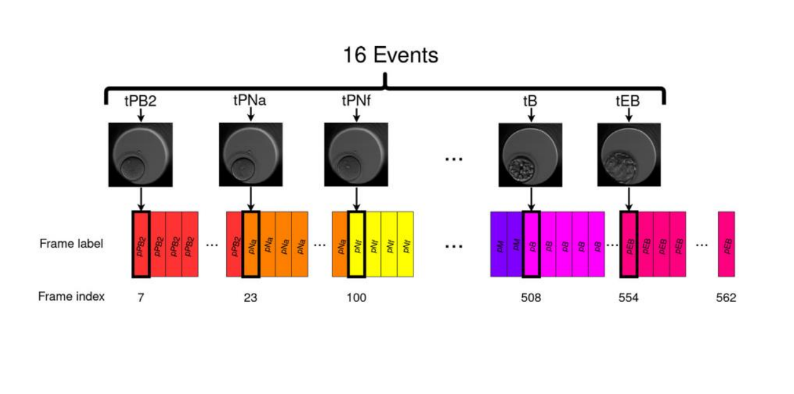

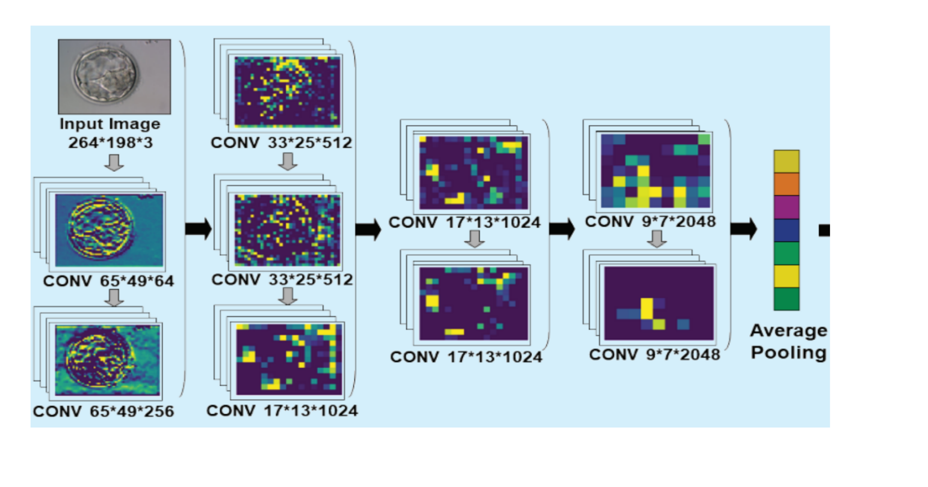

**USE DIAGRAM**

The Embryologist interacts with various use cases, including capturing time-lapse images of embryos, analyzing morphokinetic features using CNN model, receiving real-time monitoring and predictions of embryo development, and obtaining decision support for selecting the healthiest embryos during IVF. The system's functionalities aim to enhance embryo selection and improve IVF outcomes.

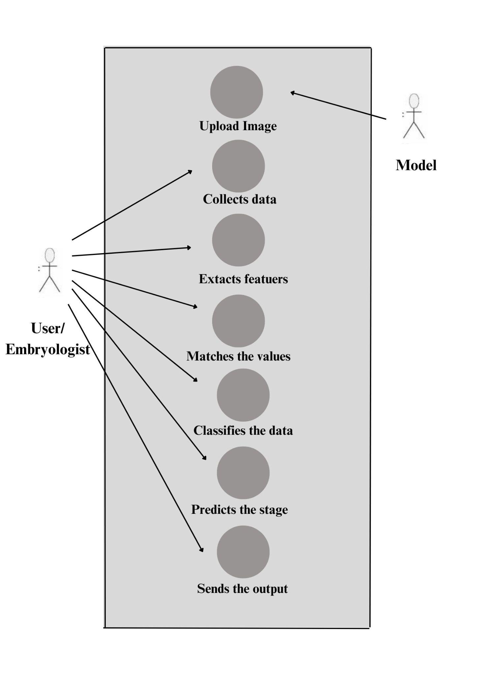

## 

## 3.2 REQUIREMENT SPECIFICATION

**3.2.1 FUNCTIONAL REQUIREMENTS**

The functional requirements of the embryo development phase prediction system play a pivotal role in shaping its design and capabilities. These requirements outline the specific functionalities and features that the system must possess to achieve its objectives effectively. By defining the necessary actions and tasks the system should perform, the functional requirements serve as a blueprint for developing a robust and reliable solution.

The functional requirements that are necessary for the model are-

1. **Data input**: The model will accept input data in the form of time-lapse images. These images are captured using time-lapse microscopy, which involves taking multiple images of the embryos at regular intervals over a period of time.
2. **Feature extraction**: The goal of feature extraction is to identify and extract the most relevant features from the pre-processed images of developing embryos that can be used to predict their stage of development. This model uses CNN(Convolutional Neural Networks) algorithm for extracting spatial features from images. The feature extraction process involves feeding the pre-processed images into the deep learning algorithm and extracting the learned features from one or more intermediate layers of the network. These features are then passed through a fully connected layer to produce a prediction of the embryo's quality.
3. **Prediction**: This involves using the extracted features to make a prediction about the stages of the developing embryo.
4. **Training**: It is a process that involves collecting and preprocessing data, selecting a model architecture, training the model and evaluating the model and refining the model as needed.
5. **Validation**: The purpose of validation is to assess the performance of the model and to ensure that it generalizes well to new data. Hence validation is a critical step in the development of this model and can help to ensure that the model is accurate, reliable, and interpretable.
6. **Performance**: The performance of the model refers to its ability to accurately predict embryo quality and provide interpretable insights into the decision-making process. There are several metrics that can be used to evaluate the performance of an embryo analysis model, including accuracy, precision, recall, etc. The performance of the model can be improved through careful model optimization and evaluation using appropriate metrics.

**3.2.2 NON FUNCTIONAL REQUIREMENTS**

Non-functional requirements are important considerations in the development of the model using CNN. These requirements relate to the model's performance, usability, and scalability, among other factors.

1. **Usability:** The model should be easy to use and integrate with existing workflows and software systems, with a user-friendly interface and clear documentation.

2. **Robustness:** The model should be robust to noise and other sources of variability in the data, with the ability to handle missing data and outliers.

3. **Scalability:** The model should be scalable, with the ability to handle large datasets and a large number of concurrent users.

4. **Reliability:** The model should be reliable, with high availability and minimal downtime, to ensure timely and accurate analysis of the development stage.

5. **Performance:** The model should be fast and efficient, with low latency and high throughput, to allow for timely analysis of large datasets.

6. **Interoperability:** It is critical to the success of the model as it enables the model to be used in conjunction with other systems and applications, and facilitates the exchange of data and information between different clinical workflows and stakeholders.

**3.3 DESIGN SPECIFICATIONS**

**3.3.1 SEQUENCE DIAGRAM**

The user (Embryologist) uploads a microscopic image of the embryo through the graphical user interface (GUI). The GUI then forwards the image to the system for analysis.Upon receiving the image, the system preprocesses it to enhance its quality and prepare it for feature extraction. The system then extracts relevant features from the image using Convolutional Neural Networks (CNNs).

After the feature extraction process, the system performs the embryo developmental stage prediction based on the extracted features. The prediction, indicating the developmental stage is then sent back to the GUI. The GUI displays the prediction as an output to the user. This output provides valuable information to the embryologist, facilitating the evaluation of the embryo's quality and development stage. The prediction aids the embryologist in making informed decisions regarding embryo selection for transfer during In Vitro Fertilization (IVF) procedures.

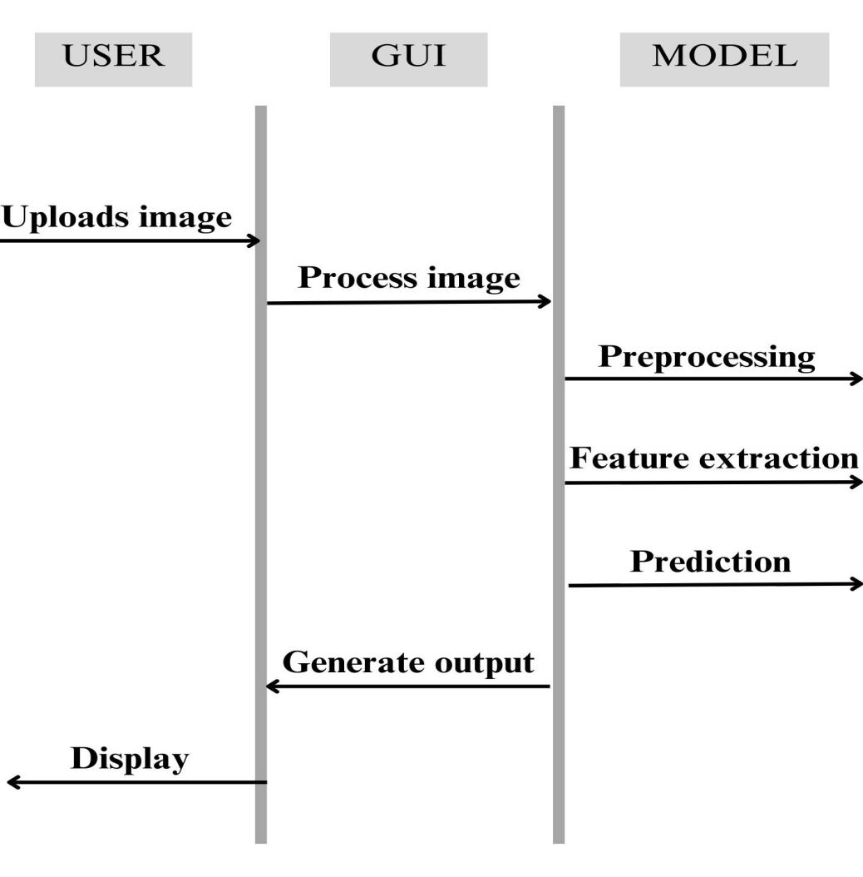

**3.3.2 ACTIVITY DIAGRAM**

The activity diagram visually represents the sequential flow of actions and interactions between the Embryologist and the system during the embryo analysis process. It illustrates how the embryo image is uploaded, processed, features are extracted, predictions are made, and results are displayed, ultimately aiding the Embryologist in decision-making for improved outcomes in assisted reproductive technologies.

The process begins with the Embryologist initiating the activity by accessing the graphical user interface (GUI) of the system. The Embryologist uploads a microscopic image of the embryo through the GUI, signifying the "Upload Image" activity. The uploaded image undergoes preprocessing by the system, represented as the "Preprocessing" activity, to enhance its quality and prepare it for feature extraction. The system proceeds with the "Feature Extraction" activity, where it extracts relevant morphokinetic features from the preprocessed image using CNNs.

The extracted features are then utilized by the model to predict the developmental stage of the embryo, denoted as the "Predict Developmental Stage" activity. The predicted developmental stage is sent back to the GUI and displayed to the Embryologist as an output. The Embryologist, upon observing the displayed prediction, makes informed decisions about the embryo's quality and selection for transfer during IVF .The activity diagram concludes with the successful display of the prediction, completing the process of embryo analysis.

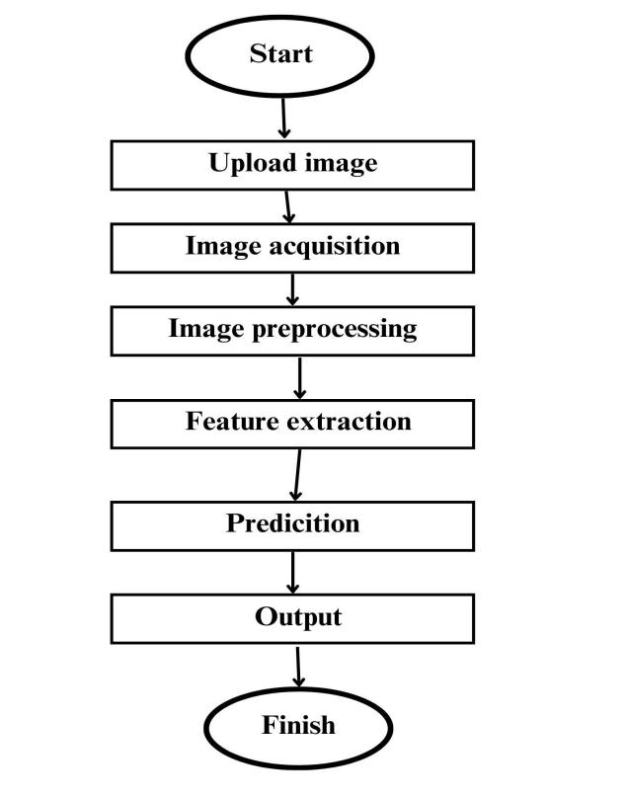

**3.3.3 USE CASE DIAGRAM**

The Embryologist interacts with various use cases, including capturing time-lapse images of embryos, analyzing morphokinetic features using CNN model, receiving real-time monitoring and predictions of embryo development, and obtaining decision support for selecting the healthiest embryos during IVF. The system's functionalities aim to enhance embryo selection and improve IVF outcomes.



**3.4 SOFTWARE AND HARDWARE REQUIREMENTS**

### SOFTWARE REQUIREMENTS

* **Programming Language:** Python
* **Deep Learning Framework:** TensorFlow is the framework used for building deep learning model with CNN.
* **Image Processing Libraries:** OpenCV, Pillow, and scikit-image are commonly used for image pre-processing and augmentation.
* **Visualization Libraries:** Matplotlib, Seaborn, and Plotly are popular libraries for data visualization and model interpretation.
* **Integrated Development Environment (IDE):** Jupyter Notebook, Visual Studio Code

### HARDWARE REQUIREMENTS

* **RAM:** The size of the dataset and the complexity of the model determine the amount of RAM required. Typically, at least 16 GB of RAM.
* **Storage:** The size of the dataset and the number of model checkpoints generated during training determine the storage requirements (an SSD is recommended for faster read/write speeds)
* **Other Hardware:** A high-resolution monitor, keyboard, and mouse are essential for developing and testing the model.

# CHAPTER-4

**IMPLEMENTATION**

## METHODOLOGY

The process begins with collecting the data from the dataset. Next, the collected data undergoes preprocessing to clean and transform it into a suitable format. Feature extraction is then performed to select informative characteristics from the preprocessed data (morphokinetic featuers). Subsequently, the model is trained using the extracted features, allowing it to learn patterns and relationships from the training data. Once trained, the model is validated on a separate dataset to assess its performance and ensure its ability to generalize to new, unseen data. This validation step is crucial for identifying potential issues and improving the model's accuracy. This concludes the process the model can be used to predict the development stage of the embryo.

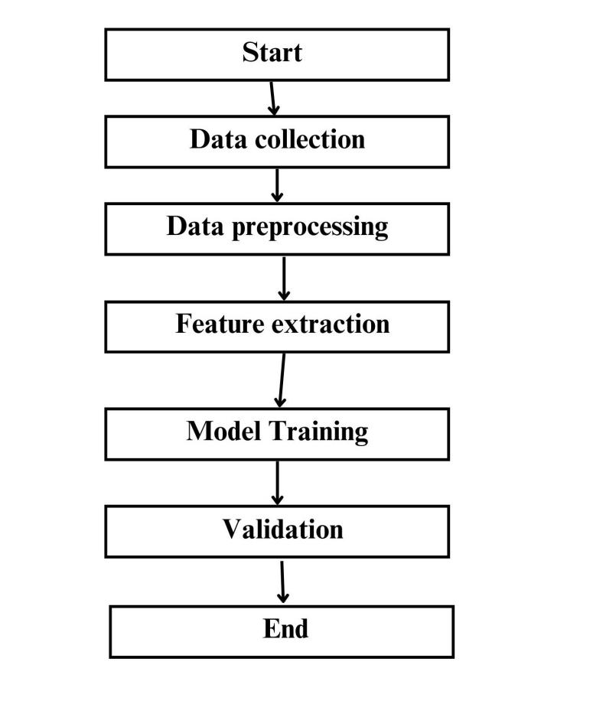

* 1. **SYSTEM ARCHITECTURE**

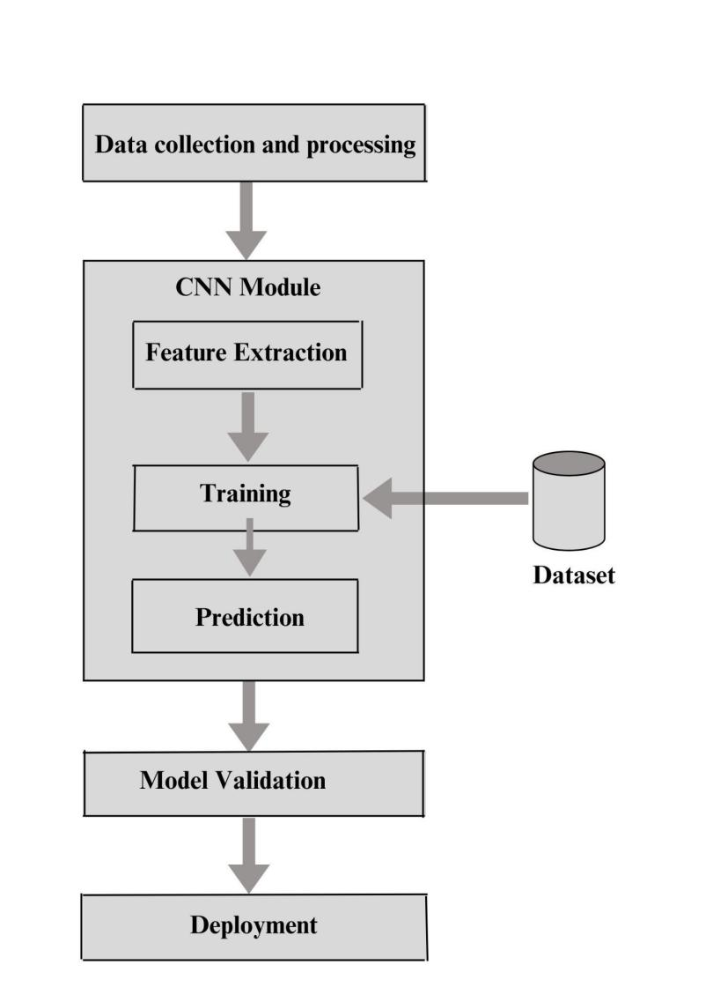

* **Data Collection and Preprocessing:** Collect the data in the form of images of embryos captured using a microscope. The images should be preprocessed to normalize them and remove any noise or artifacts present.

The dataset used for this model is composed of 704 videos, each recorded at the central focal plane, accompanied by the annotations of 16 cellular events. The images should be of the dimensions 500x500 pixels.

* **Convolutional Neural Network (CNN)**: The CNN should be designed with multiple layers of convolution and pooling, followed by fully connected layers. The CNN will learn the features from the images and predict the development stage of the embryo.
* **Model Validation:** The model is validated using a test dataset to assess its accuracy, precision, and recall.The training data consists of 12800 embryo images. The test data consists of 3200 embryo images. The validation process will help determine the effectiveness of the model and whether it can be used in a clinical setting.
* **Deployment:**
* **Model Monitoring:** The model should be monitored regularly to ensure its accuracy and performance. Model monitoring will help detect any errors or issues and enable quick remediation.

## MODULES DESCRIPTION

1. **Data Pre-processing Module:** This module is responsible for cleaning, normalizing, and pre-processing the raw embryo image data to ensure that the input to the CNN model is of high quality.

In this we created a directory structure as shown below from the un-labelled dataset used. The names of each file denote the development stage that the embryo image belongs to. All the images which depict one development stage (taken from all the time-lapse images of different embryos) are grouped in one folder. This division is used by the help of annotations folder which consists of .csv files corresponding to every embryo(which can be related by using the file names), this .csv file consists of the information about which image belongs to which development stage. This dataset is used to train the model.

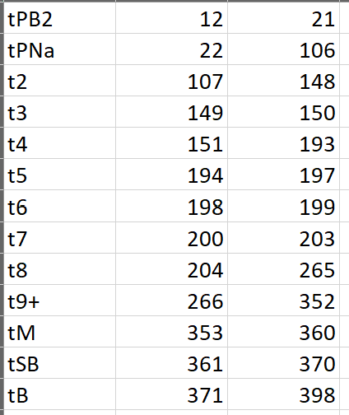

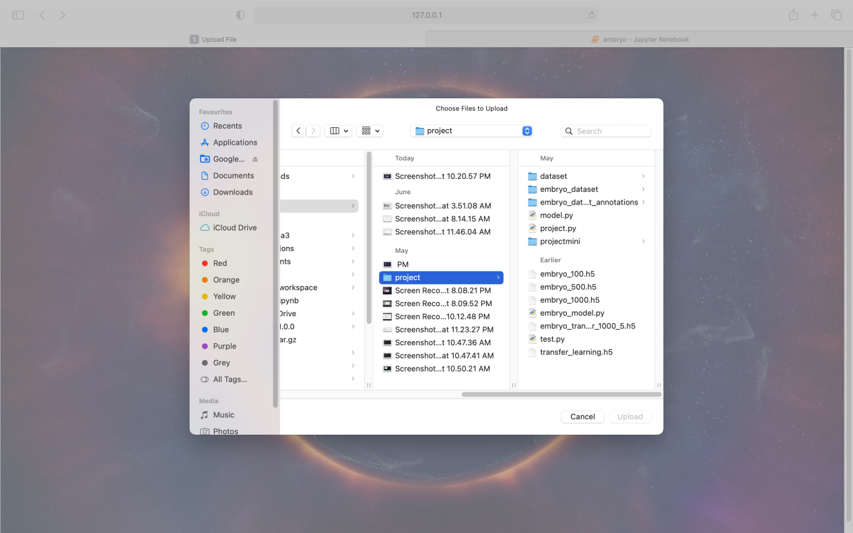

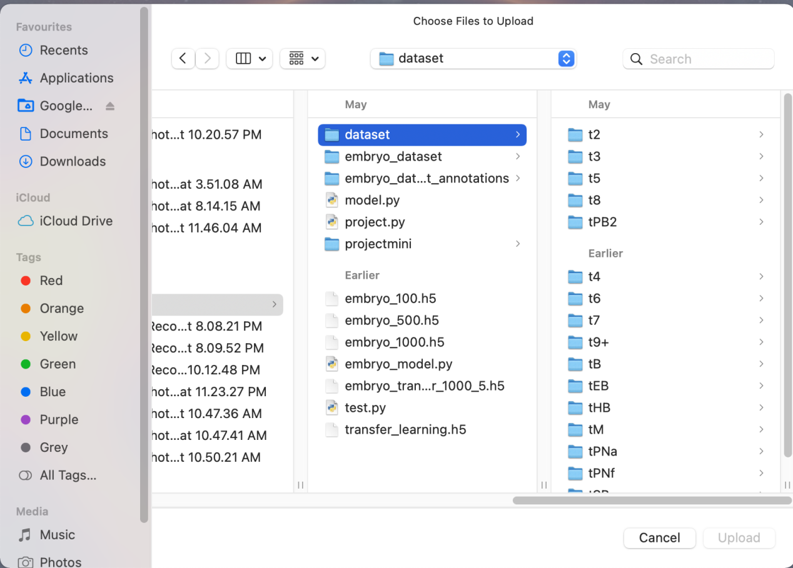

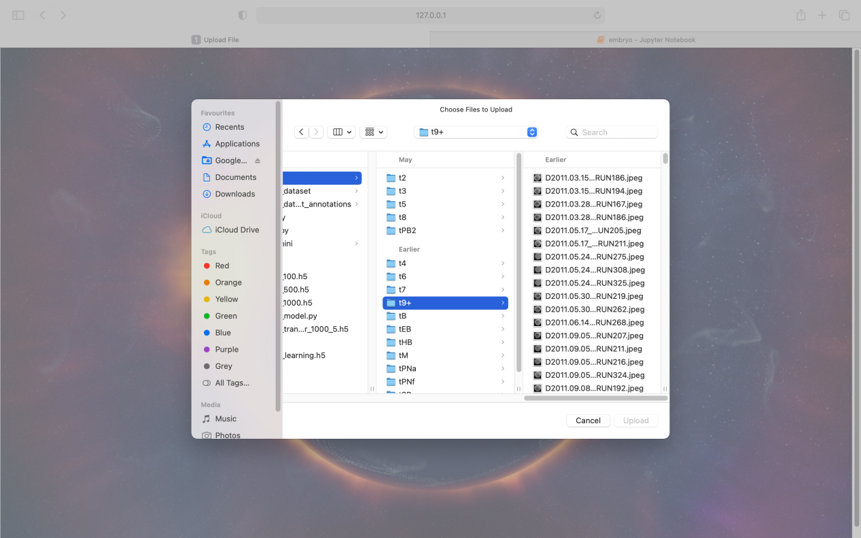

Code:

**#To organize the embryo image of the same phase into a single folder.**

**#sixteen such folders must be created.**

import os

import pandas as pd

import shutil

import re

path = "/Users/pravija/Desktop/project/embryo_dataset_annotations"

dfs = []

for filename in os.listdir(path):

if filename.endswith(".csv"):

filepath = os.path.join(path, filename)

headers=["label","start","end"]

df = pd.read_csv(filepath, names=headers)

pattern = re.compile(r'RUN(\d+)\.jpeg')

src_name = os.path.splitext(os.path.basename(filename))[0]

file_path_data="/Users/pravija/Desktop/project/embryo_dataset"

dest_dir="/Users/pravija/Desktop/project/dataset"

src_name=src_name.replace("_phases", "")

for index, row in df.iterrows():

src_path = os.path.join(file_path_data, src_name)

dest_path = os.path.join(dest_dir, row["label"])

if not os.path.exists(dest_path):

os.mkdir(dest_path)

filenames=[]

for file in os.listdir(src_path):

if pattern.search(file):

num_str = re.search(r'RUN(\d+)\.jpeg', file).group(1)

num = int(num_str)

if num >= int(row["start"]) and num <= int(row["end"]):

cp_path=os.path.join(src_path,file)

dt_path=os.path.join(dest_path,file)

shutil.copy(cp_path, dt_path)

import random

**# Set the path to the parent directory containing the subdirectories of images**

path_to_parent_directory = '/Users/pravija/Desktop/project/dataset'

**# Loop through each subdirectory**

for subdir in os.listdir(path_to_parent_directory):

subdir_path = os.path.join(path_to_parent_directory, subdir)

if os.path.isdir(subdir_path):

**# Create a list of all image file names in the subdirectory**

image_file_names = [f for f in os.listdir(subdir_path) if f.endswith('.jpeg') or f.endswith('.png')]

**# If there are more than 1000 images, randomly select 1000 and delete the rest**

if len(image_file_names) > 1000:

files_to_delete = set(image_file_names) - set(random.sample(image_file_names, 1000))

for file_name in files_to_delete:

os.remove(os.path.join(subdir_path, file_name))

**#print(row["label"],filenames)**

2. **Convolutional Neural Network Module**: This module is responsible for performing feature extraction and classification of the embryo images using a deep learning model based on convolutional neural networks (CNNs).

Code:

import os

import tensorflow as tf

from tensorflow import keras

from tensorflow.keras import layers

from tensorflow.keras.preprocessing.image import ImageDataGenerator

**#directory where the data is stored**

data_dir = "/Users/pravija/Desktop/project/dataset"

**# size of the images**

img_height = 500

img_width = 500

**# batch size for training and validation**

**# number of epochs for training**

num_epochs = 5

**# number of classes (which is the number of folders in the data directory)**

num_classes = len(os.listdir(data_dir))

train_datagen = ImageDataGenerator(

rescale=1./255,

horizontal_flip=True,

rotation_range=20,

zoom_range=0.2,

validation_split=0.2)

print(num_classes)

import os

import tensorflow as tf

from tensorflow import keras

from tensorflow.keras import layers

from tensorflow.keras.preprocessing.image import ImageDataGenerator

from tensorflow.keras.optimizers.legacy import Adam

#directory where the data is stored

data_dir = "/Users/pravija/Desktop/project/dataset"

**# size of the images**

img_height = 500

img_width = 500

# batch size for training and validation

**# number of epochs for training**

num_epochs = 5

**# number of classes (which is the number of folders in the data directory)**

num_classes = len(os.listdir(data_dir))

train_datagen = ImageDataGenerator(

rescale=1./255,

horizontal_flip=True,

rotation_range=20,

zoom_range=0.2,

validation_split=0.2)

#print(num_classes)

batch_size = 64

train_generator = train_datagen.flow_from_directory(

data_dir,

target_size=(img_height, img_width),

batch_size=batch_size,

class_mode='categorical',

subset='training')

validation_generator = train_datagen.flow_from_directory(

data_dir,

target_size=(img_height, img_width),

batch_size=batch_size,

class_mode='categorical',

subset='validation'

)

from PIL import ImageFile

ImageFile.LOAD_TRUNCATED_IMAGES = True

history = model.fit(

train_generator,

epochs=num_epochs,

validation_data=validation_generator

)

from PIL import ImageFile

ImageFile.LOAD_TRUNCATED_IMAGES = True

from tensorflow.keras import Model

base_model = keras.applications.VGG16(input_shape=(img_width, img_height, 3), include_top=False)

base_model.trainable = False

**# Adding new classification layers on top of the pre-trained model**

x = base_model.output

x = layers.GlobalAveragePooling2D()(x)

x = layers.Dense(128, activation='relu')(x)

predictions = layers.Dense(16, activation='softmax')(x)

model = Model(inputs=base_model.input, outputs=predictions)

**# Compiling the model**

model.compile(optimizer=tf.keras.optimizers.Adam(lr=0.01),

loss='categorical_crossentropy',

metrics=['accuracy'])

**# Training the model**

history = model.fit(train_generator,

epochs=10,

validation_data=validation_generator)

**# Saving the model**

model.save('/Users/pravija/Desktop/project/transfer_learning_10.h5')

model.save('/Users/pravija/Desktop/project/embryo_transfer_1000_5.h5')

model=tf.keras.models.load_model('/Users/pravija/Desktop/project/transfer_learning.h5')

3. **Prediction Module:** This module is responsible for generating predictions of embryo quality based on the features extracted by the CNN model. The predictions determine the stage of the development of that particular embryo.

Code:

def upload_file(request):

res_list=[]

if request.method == 'POST':

uploaded_file = request.FILES.get('file')

print("FILE NAME",uploaded_file)

img_path = handle_uploaded_file(uploaded_file)

print("FILE PATHHH",img_path)

img = image.load_img(img_path, target_size=(500, 500))

x = image.img_to_array(img)

x = np.expand_dims(x, axis=0)

x = preprocess_input(x)

**# Make the prediction**

predictions = model.predict(x)

print(predictions)

top_predictions = np.argmax(predictions,axis=1)

**# Get the top 5 predictions**

top_predictions=np.argsort(predictions)[0][-5:]

print(top_predictions)

#class_labels=['tB','tEB','tHB','tM','tPB2','tPNa','tPNF','tSB','t2','t3','t4','t5','t6','t7','t8','t9+']

class_labels=['tEB', 'tSB', 'tB', 't5', 'tHB', 't2', 'tM', 't3', 't4', 't9+', 't6', 't8', 'tPB2', 'tPNa', 'tPNf', 't7']

#class_labels=['t2','t3','t4','t5','t6','t7','t8','t9+','tB','tEB','tHB','tM','tPB2','tPNa','tPNF','tSB']

count=1

for pred in top_predictions:

#pred=(len(class_labels)-1)-pred

#pred=pred*-1

accuracy=predictions[0][pred]

#res_temp="Predicted class "+class_labels[pred]

res_temp="Predicted class "+class_labels[pred]+ " accuracy: "+str(accuracy)

if(accuracy!=0):

res_list.append(res_temp)

print(res_temp)

count+=1

res_list.reverse()

return render(request, 'upload_file.html',{'res_list':res_list})

4. **Interoperability Module:** This module is responsible for ensuring that the model can communicate and exchange data with other systems and applications used in clinical workflows, using standardized data formats and protocols.

5. **Performance Evaluation Module:** This module is responsible for evaluating the performance of the model on a validation dataset, using metrics such as accuracy, sensitivity, specificity, recall etc.

Code:

for pred in top_predictions:

accuracy=predictions[0][pred]

res_temp="Predicted class "+class_labels[pred]+ " accuracy: "+str(accuracy)

Output:

Epoch 1/5

189/189 [==============================] - 5697s 30s/step - loss: 8.0072 - accuracy: 0.3647 - val_loss: 7.9956 - val_accuracy: 0.3686

Epoch 2/5

189/189 [==============================] - 7847s 42s/step - loss: 8.2702 - accuracy: 0.3786 - val_loss: 8.0111 - val_accuracy: 0.3776

Epoch 3/5

189/189 [==============================] - 7162s 38s/step - loss: 8.2398 - accuracy: 0.4094 - val_loss: 7.6947 - val_accuracy: 0.4129

Epoch 4/5

189/189 [==============================] - 7351s 39s/step - loss: 7.9660 - accuracy: 0.4275 - val_loss: 8.0052 - val_accuracy: 0.4349

Epoch 5/5

189/189 [==============================] - 6799s 36s/step - loss: 8.0199 - accuracy: 0.4571 - val_loss: 7.9984 - val_accuracy: 0.4639

1. **User Interface Module:** This module is responsible for providing a user-friendly interface for clinicians to interact with the model, input new data, view predictions and explanations, and adjust model parameters as needed**.**

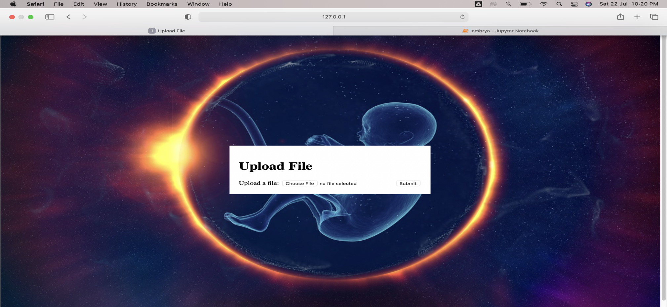

**4.4 DATASET DESCRIPTION**

The dataset used for this model is composed of 704 videos, each recorded at the central focal plane, accompanied by the annotations of 16 cellular events.

**Dataset files-** The dataset is composed of several compressed folders:

* **embryo_dataset.tar.gz** contains 704 folders, each containing all the frames of one video. An embryo is a 3D object and the focal plane of the microscope can be changed to better visualize the embryo. This compressed folder contains images recorded at the central focal plane called F0. The images are JPEG files in shades of gray with a 500 × 500 resolution.

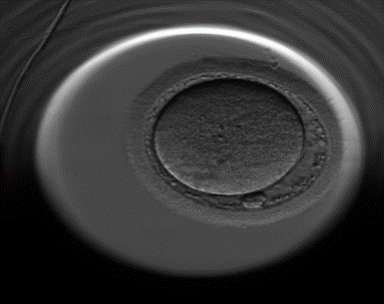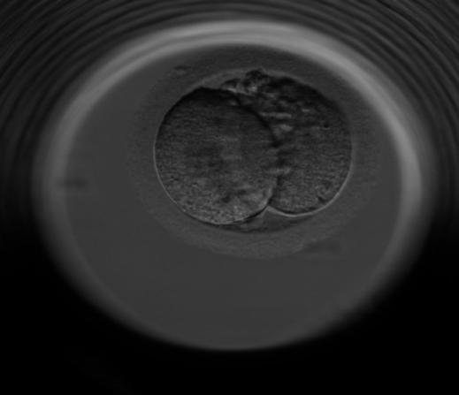

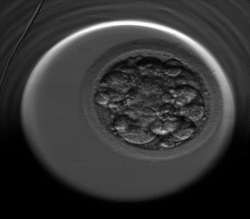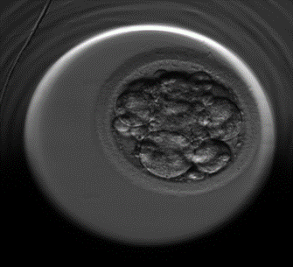

* **embryo_dataset_annotations.tar.gz** contains the 704 CSV annotations files. Each CSV is the annotation of one video and has three columns: phase, start frame index and end frame index that indicates the frame interval of each phase.

Example of an annotation .csv file-



# CHAPTER-5

## TEST PLAN (SPECIFIC FOR THIS PROJECT)

## TEST CASES

Test Case Format

|  |  |  |  |  |  |  |  |
| --- | --- | --- | --- | --- | --- | --- | --- |
| **Test Case ID** | **Test Case Name/Objective** | **Prerequisites/**  **pre-condition** | **Test Description/**  **Testing Process** | **Expected Result** | **Actual Result** | **Pass/Fail/Not executed/ suspended** | **Action/Notes** |
| **1** |  |  |  |  |  |  |  |
|  |  |  |  |  |  |  |  |
|  |  |  |  |  |  |  |  |

# CHAPTER 6

**RESULTS AND CONCLUSION**

## Result Analysis

The user has to upload an image, this image must be a microscopic image of an embryo.

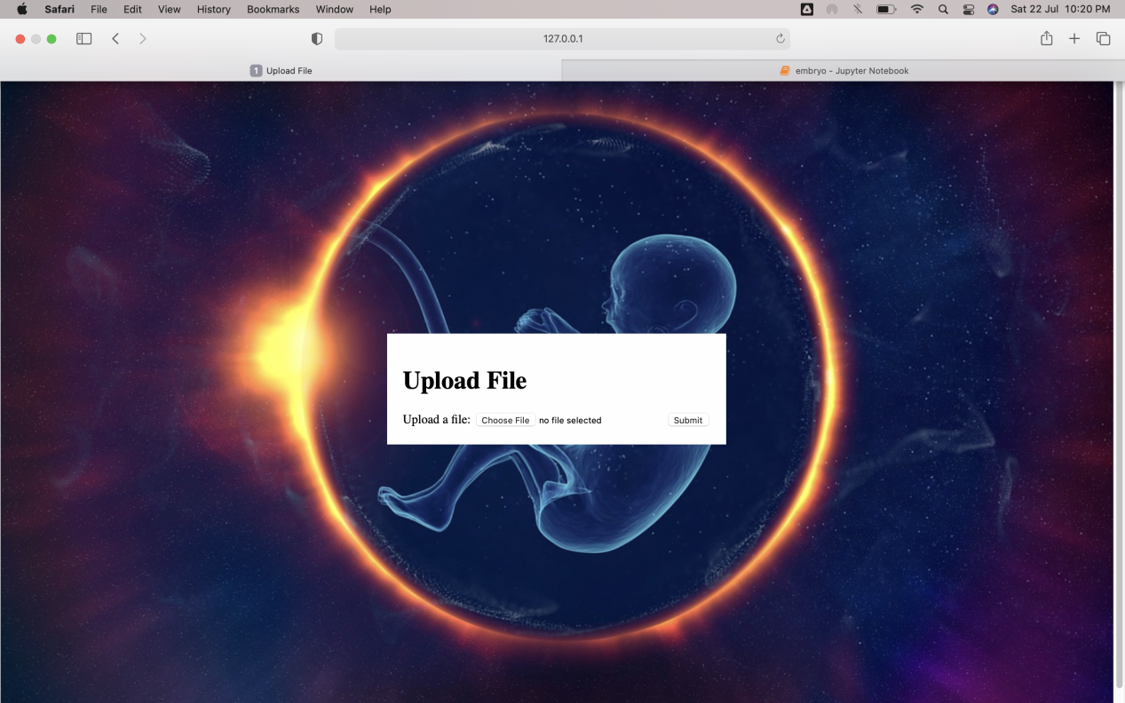

The resolution the uploaded image file must be 500 x 500 pixels.

The image is uploaded from the pre-processed and transformed dataset containing folders for corresponding phases.

Each phase folder consists of all the embryo images present in the dataset corresponding to the same phase.







The selected image must be submitted to obtain the stage prediction of the embryo present in the image.

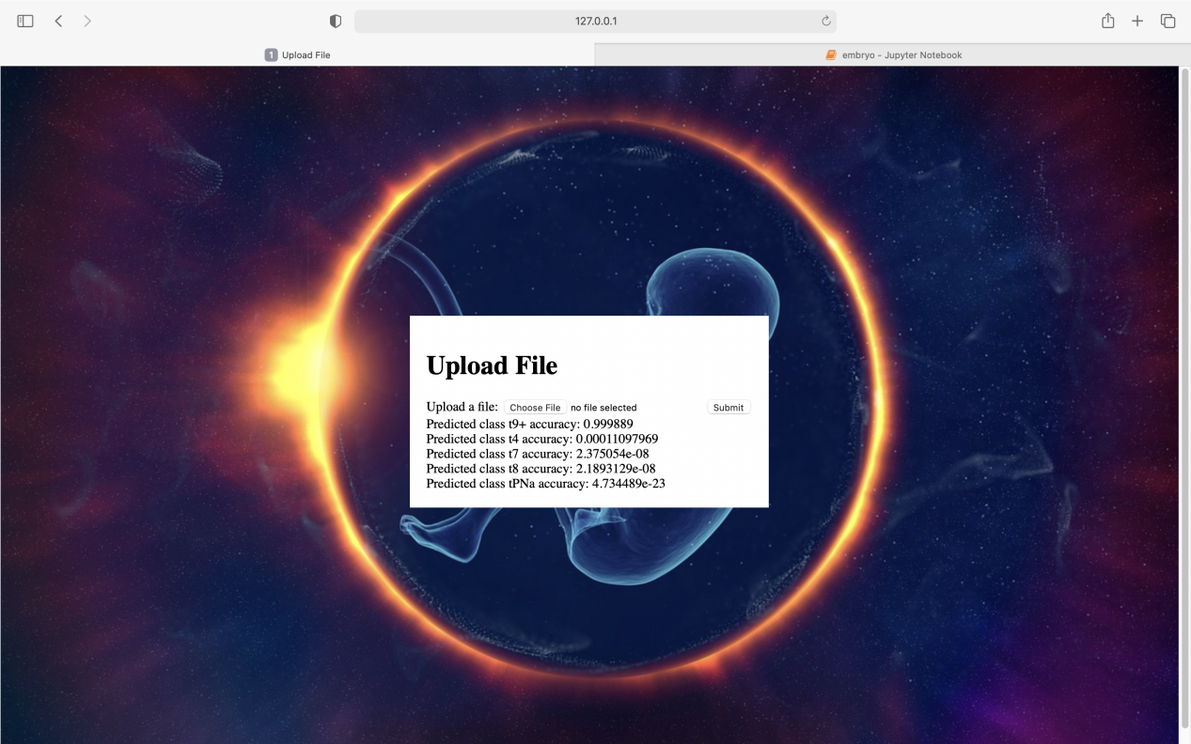

The output obtained consists of the top five predicted stages of the embryo present in the uploaded image.

The accuracy of each stage predicted is also presented on the interface.

The predicted stage with highest accuracy is chosen.

## Conclusion and Future Scope

### Conclusion

In conclusion, the development of an advanced embryo development phase prediction system employing deep learning methodologies presents a significant opportunity to revolutionize the field of assisted reproduction, specifically In Vitro Fertilization (IVF). The system utilizes Convolutional Neural Networks (CNNs) to analyze time-lapse images captured during the IVF process, accurately predicting and classifying various developmental stages of embryos. By automating embryo annotation and evaluation, the system streamlines workflows for fertility specialists and embryologists, enabling them to focus on patient care and decision-making. This project prioritizes data preprocessing, feature extraction, and real-time predictions to ensure efficient and timely embryonic development analysis. Through rigorous model training, validation, and optimization, the system aims to enhance accuracy and reliability. With scalability and seamless integration into clinical workflows as key objectives, the system offers a seamless and effective solution for IVF clinics, empowering healthcare professionals to provide exceptional patient care. As this model progresses, it is expected to contribute significantly to the enhancement of IVF success rates, providing hope and joy to individuals and couples facing infertility challenges. By advancing the frontiers of reproductive medicine, this cutting-edge system has the potential to fulfill the dreams of countless families worldwide, making the journey to parenthood a reality for those seeking assisted reproduction solutions. Overall, the project's successful implementation is poised to bring about transformative advancements in the field, empowering both medical professionals and hopeful families on their path to building happy and healthy families.

### Future Scope

The ability to predict embryo development phase using deep learning has the potential to revolutionize the field of assisted reproductive technology (ART).The use of deep learning to predict embryo development phase could help to improve the accuracy of embryo selection and reduce the number of embryos that are discarded. This could lead to an increase in the success rates of ART, and it could also make ART more affordable.

In addition to improving the accuracy of embryo selection, the use of deep learning could also be used to develop new ways to monitor embryo development. For example, deep learning could be used to identify embryos that are at risk of developing problems during their development. This information could then be used to take steps to improve the chances of these embryos developing into healthy babies.

* To personalize ART treatment: The project could be used to personalize ART treatment for individual patients. This could involve using the information from the project to select the best embryos for transfer, or it could involve using the information from the project to adjust the ART treatment protocol.
* To develop new ways to monitor embryo development: The project could be used to develop new ways to monitor the development of embryos over time. This could help to identify embryos that are at risk of developing problems during their development, and it could also help to identify embryos that are developing normally.
* Integration with Explainable Artificial Intelligence (XAI) Techniques: As the field of XAI continues to evolve, incorporating advanced XAI techniques into the embryo development phase prediction model will be a vital area of future development. By providing interpretable and transparent insights into the model's decision-making process, XAI techniques will enhance the trustworthiness and adoption of the model among fertility specialists, embryologists, and patients. The visualization of important features and the identification of influential regions in the images will contribute to a deeper understanding of how the model arrives at its predictions, making the system more clinically relevant and useful.
* International Collaborations and Multi-Center Studies: Collaborations between IVF clinics, research institutions, and international organizations can lead to the creation of large-scale, multi-center datasets. These collaborations will ensure the model's applicability across diverse populations and IVF practices, making it a globally relevant and widely accepted tool for embryo analysis.
* Integration with Electronic Health Records (EHRs) and Clinical Decision Support Systems: Integrating the embryo development phase prediction model with Electronic Health Records (EHRs) and clinical decision support systems can facilitate seamless data exchange and workflow integration in IVF clinics. By providing real-time predictions and insights during the IVF process, the model will aid clinicians in making informed decisions about embryo selection, timing of transfers, and treatment planning. This integration will enhance the clinical efficiency and effectiveness of IVF procedures.

# APPENDIX

## Screenshots representing the flow of project:







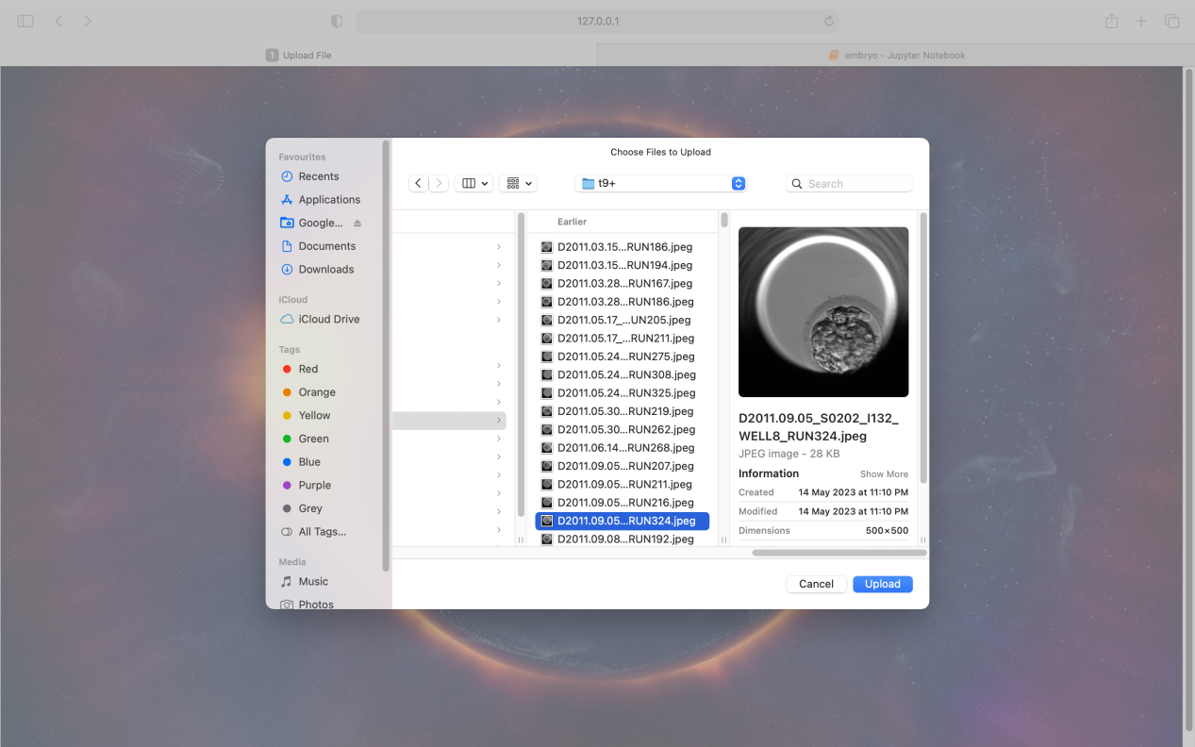



## II.Code

import os

import tensorflow as tf

from tensorflow import keras

from tensorflow.keras import layers

from tensorflow.keras.preprocessing.image import ImageDataGenerator

#directory where the data is stored

data_dir = "/Users/pravija/Desktop/project/dataset"

# size of the images

img_height = 500

img_width = 500

# batch size for training and validation

# number of epochs for training

num_epochs = 10

# number of classes (which is the number of folders in the data directory)

num_classes = len(os.listdir(data_dir))

train_datagen = ImageDataGenerator(

rescale=1./255,

horizontal_flip=True,

rotation_range=20,

zoom_range=0.2,

validation_split=0.2)

print(num_classes)

import os

import tensorflow as tf

from tensorflow import keras

from tensorflow.keras import layers

from tensorflow.keras.preprocessing.image import ImageDataGenerator

from tensorflow.keras.optimizers.legacy import Adam

#directory where the data is stored

data_dir = "/Users/pravija/Desktop/project/dataset"

# size of the images

img_height = 500

img_width = 500

# batch size for training and validation

# number of epochs for training

num_epochs = 10

# number of classes (which is the number of folders in the data directory)

num_classes = len(os.listdir(data_dir))

train_datagen = ImageDataGenerator(

rescale=1./255,

horizontal_flip=True,

rotation_range=20,

zoom_range=0.2,

validation_split=0.2)

#print(num_classes)

batch_size = 64

train_generator = train_datagen.flow_from_directory(

data_dir,

target_size=(img_height, img_width),

batch_size=batch_size,

class_mode='categorical',

subset='training')

validation_generator = train_datagen.flow_from_directory(

data_dir,

target_size=(img_height, img_width),

batch_size=batch_size,

class_mode='categorical',

subset='validation'

)

from PIL import ImageFile

ImageFile.LOAD_TRUNCATED_IMAGES = True

history = model.fit(

train_generator,

epochs=num_epochs,

validation_data=validation_generator

)

from PIL import ImageFile

ImageFile.LOAD_TRUNCATED_IMAGES = True

from tensorflow.keras import Model

base_model = keras.applications.VGG16(input_shape=(img_width, img_height, 3), include_top=False)

base_model.trainable = False

# Adding new classification layers on top of the pre-trained model

x = base_model.output

x = layers.GlobalAveragePooling2D()(x)

x = layers.Dense(128, activation='relu')(x)

predictions = layers.Dense(16, activation='softmax')(x)

model = Model(inputs=base_model.input, outputs=predictions)

# Compiling the model

model.compile(optimizer=tf.keras.optimizers.Adam(lr=0.01),

loss='categorical_crossentropy',

metrics=['accuracy'])

# Training the model

history = model.fit(train_generator,

epochs=10,

validation_data=validation_generator)

# Saving the model

model.save('/Users/pravija/Desktop/project/transfer_learning_10.h5')

model.save('/Users/pravija/Desktop/project/embryo_transfer_1000_5.h5')

model=tf.keras.models.load_model('/Users/pravija/Desktop/project/transfer_learning.h5')

#assembling into each phase folders

import os

import pandas as pd

import shutil

import re

path = "/Users/pravija/Desktop/project/embryo_dataset_annotations"

dfs = []

for filename in os.listdir(path):

if filename.endswith(".csv"):

filepath = os.path.join(path, filename)

headers=["label","start","end"]

df = pd.read_csv(filepath, names=headers)

pattern = re.compile(r'RUN(\d+)\.jpeg')

src_name = os.path.splitext(os.path.basename(filename))[0]

file_path_data="/Users/pravija/Desktop/project/embryo_dataset"

dest_dir="/Users/pravija/Desktop/project/dataset"

src_name=src_name.replace("_phases", "")

for index, row in df.iterrows():

src_path = os.path.join(file_path_data, src_name)

dest_path = os.path.join(dest_dir, row["label"])

#print(dest_path)

if not os.path.exists(dest_path):

os.mkdir(dest_path)

filenames=[]

for file in os.listdir(src_path):

if pattern.search(file):

num_str = re.search(r'RUN(\d+)\.jpeg', file).group(1)

num = int(num_str)

if num >= int(row["start"]) and num <= int(row["end"]):

cp_path=os.path.join(src_path,file)

dt_path=os.path.join(dest_path,file)

shutil.copy(cp_path, dt_path)

#filenames.append(file)

import random

# Set the path to the parent directory containing the subdirectories of images

path_to_parent_directory = '/Users/pravija/Desktop/project/dataset'

# Loop through each subdirectory

for subdir in os.listdir(path_to_parent_directory):

subdir_path = os.path.join(path_to_parent_directory, subdir)

if os.path.isdir(subdir_path):

# Create a list of all image file names in the subdirectory

image_file_names = [f for f in os.listdir(subdir_path) if f.endswith('.jpeg') or f.endswith('.png')]

# If there are more than 1000 images, randomly select 1000 and delete the rest

if len(image_file_names) > 1000:

files_to_delete = set(image_file_names) - set(random.sample(image_file_names, 1000))

for file_name in files_to_delete:

os.remove(os.path.join(subdir_path, file_name))

#print(row["label"],filenames)

Views.py

from django.shortcuts import render

from django.http import HttpResponse

import numpy as np

import os

import tensorflow as tf

import tempfile

# from tensorflow.keras.preprocessing import image

# from tensorflow.keras.applications.resnet50 import preprocess_input, decode_predictions

from tensorflow.keras.preprocessing import image

from tensorflow.keras.applications.resnet50 import preprocess_input, decode_predictions

model = tf.keras.models.load_model('/Users/pravija/Desktop/project/transfer_learning.h5')

# Create your views here.

# def upload_file(request):

# if request.method == 'POST':

# file = request.FILES.get('file')

# print("FILEE",file)

# # if file:

# # model = tf.keras.models.load_model('/Users/pravija/Desktop/project/transfer_learning.h5')

# # print("MODEL",model.summary())

# return render(request,'upload_file.html')

def upload_file(request):

res_list=[]

if request.method == 'POST':

uploaded_file = request.FILES.get('file')

print("FILE NAME",uploaded_file)

img_path = handle_uploaded_file(uploaded_file)

print("FILE PATHHH",img_path)

img = image.load_img(img_path, target_size=(500, 500))

x = image.img_to_array(img)

x = np.expand_dims(x, axis=0)

x = preprocess_input(x)

# Make the prediction

predictions = model.predict(x)

print(predictions)

top_predictions = np.argmax(predictions,axis=1)

# Get the top 5 predictions

#print(np.argsort(predictions))

top_predictions=np.argsort(predictions)[0][-5:]

print(top_predictions)

#class_labels=['tB','tEB','tHB','tM','tPB2','tPNa','tPNF','tSB','t2','t3','t4','t5','t6','t7','t8','t9+']

class_labels=['tEB', 'tSB', 'tB', 't5', 'tHB', 't2', 'tM', 't3', 't4', 't9+', 't6', 't8', 'tPB2', 'tPNa', 'tPNf', 't7']

#class_labels=['t2','t3','t4','t5','t6','t7','t8','t9+','tB','tEB','tHB','tM','tPB2','tPNa','tPNF','tSB']

count=1

for pred in top_predictions:

#pred=(len(class_labels)-1)-pred

#pred=pred*-1

accuracy=predictions[0][pred]

#res_temp="Predicted class "+class_labels[pred]

res_temp="Predicted class "+class_labels[pred]+ " accuracy: "+str(accuracy)

if(accuracy!=0):

res_list.append(res_temp)

print(res_temp)

count+=1

res_list.reverse()

# return render(request, 'upload_file.html', {'img_path': img_path})

return render(request, 'upload_file.html',{'res_list':res_list})

def handle_uploaded_file(uploaded_file):

with tempfile.NamedTemporaryFile(delete=False) as temp_file:

temp_file.write(uploaded_file.read())

return temp_file.name

Urls.py

from django.urls import path, include

from . import views

urlpatterns = [

path('',views.upload_file, name="upload_file"),

]

**III. Bibliography/References:**

